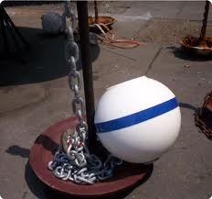
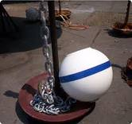
Jeff Putnam 650-3327

Haul up and service your mooring

I can put in or check your morning this spring. If needed I can change out the chain and do minor repairs, will provide pictures by e-mail of the mooring condition and work that was done.
My boat is equipped with a winch that can haul up to 4000 pounds
$65 to haul the mooring, any work done is an additional cost

Jeff Putnam
650-3327
Mooring Inspection

