Chebeague Pre-K- Transitional K News - February 27, 2009

Despite the snow day we still celebrated George Washington. After so much effort around Abe Lincoln I didn’t think we could pass over Washington. I summarized a book and brought attention to his presence on the one dollar bill and quarter. I sent home the heads and tails coin flip game in your child’s folder. You can use 10 Popsicle sticks, tooth picks, pebbles or any type of counter. The goal is to count how many were heads and how many tails (1:1 counting) and describe which had more, heads or tails. If your child is still developing his/her numeration skills lining each group of counters up will facilitate counting and give a visual of which group has more. You can easily make a game for other coins too. You can glue down a coin showing heads or tails if you don’t want to attempt illustration.
We made the letter “w” with the 4 sticks from Mat Man (2 arms & 2 legs) and completed a w page in our journals.
We concluded our reptile unit by exploring how a snake hears through vibrations and how it can hardly see when it sheds its skin. We are now learning about a few dinosaurs. This week a few of the earliest dinosaurs, Apatosaurus and Stegosaurus appeared in the dramatic play area. We will talk about these vegetarians some more before any meat eaters appear on the shelf. Thanks to Carol White for sharing her dinosaur replicas.
Our Friday craft project with Jamie Calthorpe was making dinosaur fossils in mud (plastic dinosaur imprints into play dough, then adding plaster of paris). After they rest for a pretend million year or so we will unearth the remains. Thank you Jamie!

Our new works this week:
Language
- Letter sound “w”
- Pin punching dinosaur shapes

Practical Life/Art
- Sorting glass stones by color
- Painting with a paintbrush
- Coin rubbing - quarter

Math
- Dinosaur counting works – Apatosaurus to 7 and Ty Rex nests and eggs to 10

Science
- Introduction to Dinosaurs
- Fossil making activity with Jamie Calthorpe

History
- Pangaea – one continent a LONG time ago

Geography
- New land and water forms: Isthmus & Strait

Music
- We are listening to Haydn at lunch.
- Movement this week was squeezed out with the snow day.

Peace
- We continued with “themselves” as peacemakers with a work focusing on them being a part of something much bigger. I have series of 8 nesting boxes going from the Universe, Solar system, Earth, North America, United States, Maine, Town of Chebeague, Chebeague Island School to a wooden heart inside the school box representing them.

*Our next new letter sound will be “o”.

Calendar updates:
March 8: Daylight savings time begins
March 13: Island Commons visit

Notices:
Many children opted for dry clothes after recess on Friday. If your child came home in different socks or pants, please look for the bag of wet clothes in their backpack and send in dry backups with their folders on Monday. Please remind them that they have the clothes so that we can help them be independent replenishing their change of clothes box.

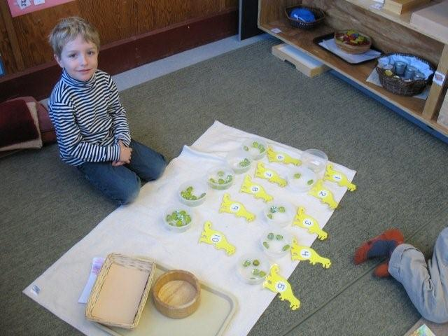
Dinosaur counting work – Ty Rex nest eggs

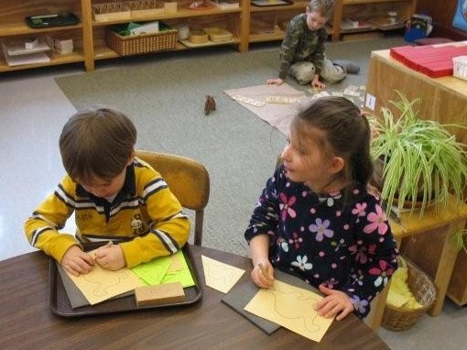
Pin punching dinosaurs – develops fine motor writing skills

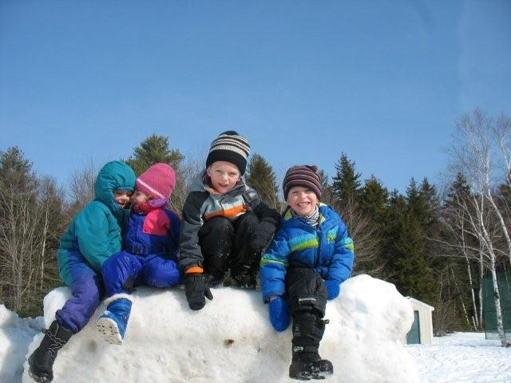
Riding the dinosaur at recess
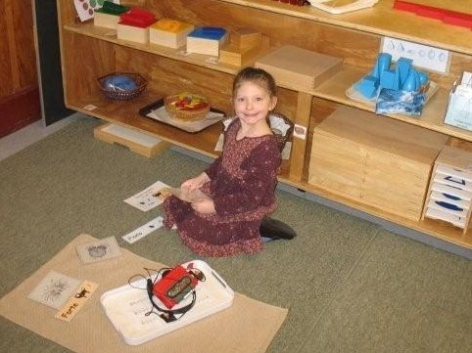
Forte and Piano work with Haydn’s Surprise Symphony

Thank you for sharing your children
Miss Nancy, Miss Cheryl

