Chebeague Pre-K- Transitional K News - October 24, 2008

This week we did a lot with parts of a plant. They have all enjoyed our new puzzle and many have matched the plant part pictures. They can also make their own book coloring in the various plant parts – roots, stem, branches, leaves.
Sally’s project on Monday was to follow up our work at circle building a structure with balance. During circle the children used our classroom blocks. Individually they had small wood scraps. Later in the week our two second year students joined the K-2 art class to learn about Louise Nevelson and paint their structures.
On Thursday all CIS students joined together to clear dead plant debris and rocks from the garden. It was a wonderful cooperative effort. We know more rocks will appear over time but that is part of learning about growing food on Chebeague.
Friday was a busy day. Jamie Calthorpe joined us to help the children add land to their globes. They tore paper bags and made their own continents. At our peace circle Leila Bisharat joined us to talk about the formation of the United Nations, its flag and its goals for peace.
Looking ahead – on Thursday, Oct. 30 we will be making Stone Soup. Please send in one food item to be added to the soup. (Potato, carrot, peas, celery, corn, broccoli, tomato are possibilities). We will make the soup, slow cook it and then have it for snack on Friday.
On Friday, Oct. 31. We will all ride together in Miss Nancy’s van leaving school at 11:10, returning in time for lunch. Please send car seats with your child to school. Costumes may be worn for the entire school day assuming they can still manage the bathroom independently. If not send their costume in their backpack and we will help them get dressed for our field trip to the Commons. No weapons.
At this point I don’t have any more information about the Contra dance at school on Friday afternoon but I will e-mail you as I know more.
This week’s circle presentations:

Language
- Letter “p” sound
- Chalkboard writing of names with chalk.
- Stone Soup Story retelling

Practical Life/Art
- Finger painting and making prints
- Sponge squeezing
- Wet pouring
- Louise Nevelson wood and glue project – cultivating an awareness of balance

History
- Formation of the United Nations

Geography
- Adding land to our globes

Science
- Puzzle – parts of a plant
- Parts of a Plant – Three part matching and book making
Music
- Lunchtime listening – Beethovan
- Steady beat work, tick/tock and alarm
- Pass the bean bag rhythm poem
- Beanie Bag Dance for movement

Peace
- United Nations Day presentation

Next week our new letter sound will be “c”.

Calendar updates:
October 31 – Island Commons Field Trip-11:10
October 31 – Halloween Contra dance at school with the elementary children. Our class is invited WITH a grown up -time TBA – possibly 2-3pm.
Nov. 17-20: Parent/Teacher conferences
Nov. 18: 7-8:30- Community school open house

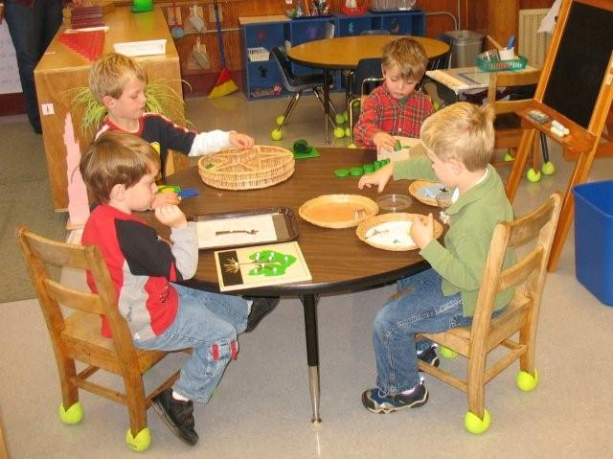
Each doing a work of their choice

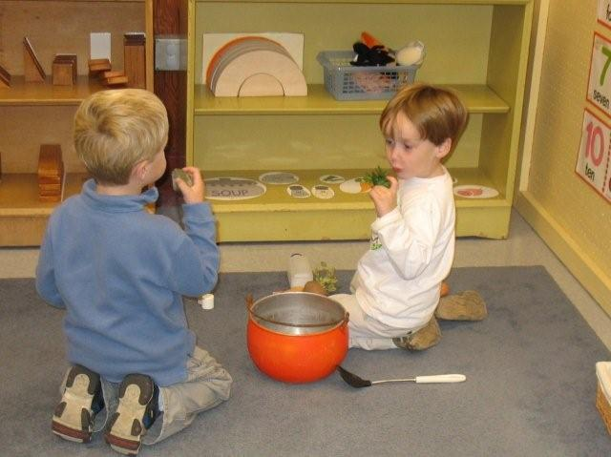
Making Stone Soup

Thank you for sharing your children
Miss Nancy, Miss Cheryl

