Chebeague Pre-K- Transitional K News - October 17, 2008

The children did a great job remembering why we had a holiday on Monday and they continue to choose the Columbus game board activity.
We focused on triangles this week and discovered how two triangles can make a star. During our transition times we have been doing the Five Little Pumpkins finger play.
We have spent a lot of time this week journaling and talking about fire safety and family meeting places. Also if your clothes are on fire…. stop, drop and roll. If smoky - stay low, under the smoke, in order to breathe better air. Please continue to remind your children that in the event of a fire: get out and stay out. Also please practice going to your family meeting place. Put reminders on your calendar to practice at least four times a year with young children.
.
This week’s circle presentations:
Language
- Pumpkin and ghost pin punching
- Eric Carle’s Rooster Off to See the World story retelling work
- Chalkboard writing with a wet finger.

Sensorial
- Knobless cylinders which grade thick to thin and tall to short in various combinations. These work together with the knobbed cylinders we already have on the shelf.

Math
- Hanging bead stair – sequencing beads and numerals 1-9.
- Money poem and sorting coins: pennies, nickels, dimes and quarters

Practical Life/Art
- Zipper dressing frame
- Large button dressing frame

History
- October full moon – The Hunter’s Moon

Geography
- Land, Air, Water book making (cutting, sorting and pasting animals into habitat groups).

Science
- Parts of a Plant – stems. We are watching colored water transform the leaves of our celery stalks red and blue. We measured how many students it took to match the height of the sunflower plant I brought in.
- In our nature classroom we looked for, and then shared items in nature that matched our various color cards.
Music
- Lunchtime listening – Bach
- Disco Limbo for movement

Peace
- New Yoga poses – Tree and Squirrel
- We grew from seeds to trees and floated/ twirled like falling leaves.

Next week our new letter sound will be “p”. With the short week we skipped over presenting a new letter this week.

Calendar updates:
October 24 – United Nations Day circle, lunch with the elementary children.
October 25 – CPA Halloween party 6:30 – 8
October 31 – Island Commons Field Trip-11:10
October 31 – Halloween Contra dance at school with the elementary children. Our class is invited WITH a grown up -time TBA – possibly 2-3pm.
Nov. 17-20: Parent/Teacher conferences
Nov. 18 – 7-8:30: Community school open house

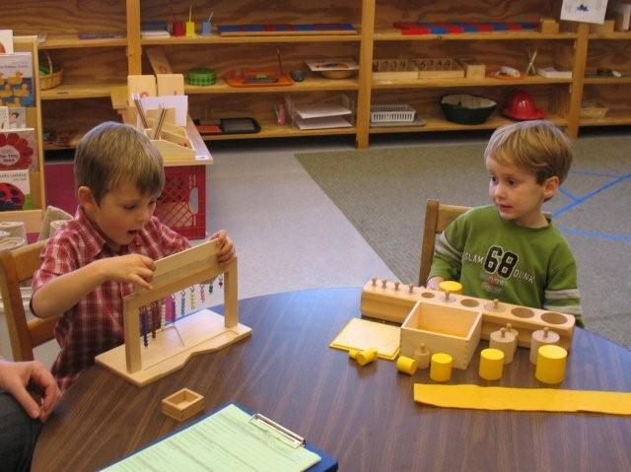
Hanging bead stair (left)
knobbed and knobless cylinder (right)

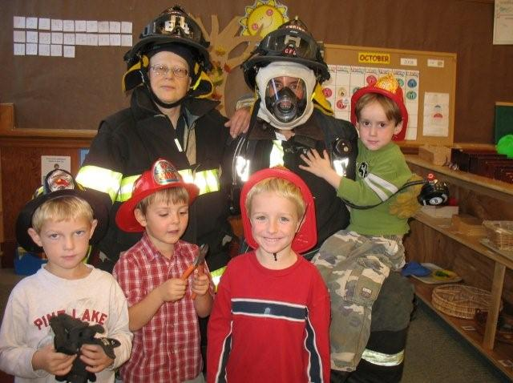
Fire Safety with Miss Ginny and Miss Nancy

Thank you for sharing your children
Miss Nancy, Miss Cheryl

