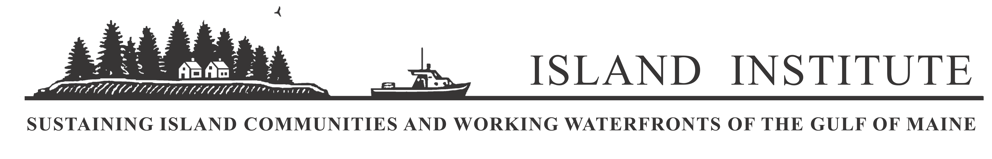

News Release
Bill McKibben to Speak in Rockland on October 14

For Immediate Release: September 22, 2011
Contact: Nancy McLeod Carter, (207) 594-9209, ext. 133

Bill McKibben, one of America's best-known environmentalists and authors, will kick off the Island Institute’s fourth Annual Sustainable Island Living Conference on Friday, October 14 at 6:30 p.m. at the Strand Theatre on Main Street in Rockland. Bill’s global grassroots nonprofit organization 350.org has revolutionized the dialogue around climate change and political action. A seasoned and inspirational speaker and author of two best-selling books, The End of Nature and Deep Economies: The Wealth of Communities, Earth, and the Durable Future, Bill is in great demand world-wide – his talk on October 14 will be his only appearance in Maine in 2011.

This year’s Sustainable Island Living Conference will also feature two other nationally known experts along with informative sessions on economic development, leadership, and civic engagement. Each year, the conference brings year-round island and coastal residents together with regional and national experts to discuss strategies for sustainability and economic vitality in remote communities along the Maine coast.

At 9:00 a.m. on Saturday, October 15th, Ben Hewitt, author of The Town That Food Saved: How One Community Found Vitality in Local Food (Rodale) will launch the day’s activities. Ben speaks on issues relating to localized food systems and economies, and is known for his thoughtful, inspiring, and occasionally hilarious presentations. The rest of the day will feature several workshops and discussions designed to give participants the chance to share knowledge and skills in a variety of topical areas.

On Sunday, October, 16, a one-day Leadership Summit – new to the conference this year – will feature Rick Gilkey, professor of organization and management at Emory University. Dr. Gilkey has served as an editorial consultant to The New York Times and Fortune Magazine as well as a consultant to such organizations as Coca-Cola, General Electric, IBM, Johnson & Johnson, CARE, and the U.S. Department of State.

There are several options for registration. The fee for Friday evening and Saturday is $40 per person for island residents and $60 for non-island residents. The Sunday leadership summit is $10 per person. It’s also possible to purchase tickets just for Bill’s Friday evening presentation for $10 per person. Online registration is located at http://www.islandinstitute.org/silconference.

For more information, please contact Sally Perkins at sperkins@islandinstitute.org.
##
The Island Institute partners with Maine’s year-round island and working-waterfront communities
to ensure that they remain vibrant places to live, work, and educate children.

