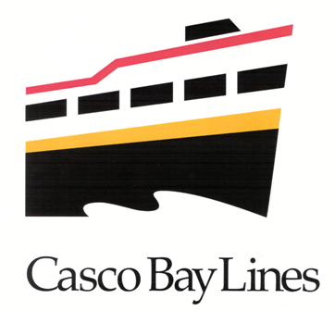

Casco Bay Lines service from Chebeague Island

- Spend a Friday evening in Portland!

On Fridays, take the 4:15 PM boat from Chebeague Island to Portland. You will arrive in Portland at about 5:15 PM – with plenty of time to dine in the Old Port, shop in the Old Port’s unique galleries and stores, or catch a movie at the Nickelodeon theatre. You might prefer to go to the Portland Museum of Art - where on Friday nights admission is free. The “DownBay” boat departs from Portland at 10:30 PM for the return trip to
Chebeague Island.

- Nickelodeon Movie Theatre, 1 Temple St., Portland, ME; 772-9751
http://www.patriotcinemas.com/nickelodeon.html

- Portland Museum of Art, 7 Congress St., Portland, ME; 775-4168
http://www.portlandmuseum.org/

- Every Friday in July and August - EVENINGS AT THE GARDEN SUMMER JAZZ SERIES at the Portland Harbor Hotel, 6-9 PM, 468 Fore St.; 775-9090. Check out the line-up at http://www.gbritt.com/release.php?r=382

- Take a Saturday Shopping Trip to Portland!

On Saturday morning, depart Chebeague Island at 8:10 AM. You will arrive in Portland at approximately 9:20 AM. Spend the morning shopping in the Old Port’s unique galleries and stores. Have lunch in one of the Old Port’s many well-known restaurants. You might want to visit the Portland Museum of Art (see address, telephone number, and website above). Or catch a bus to the Deering Oaks Farmer’s Market – open
Saturdays until noon.

On Saturday, “DownBay” boats returning to Chebeague Island depart from the Terminal at 2:15 PM and 5:45 PM. If you have enough shopping bags that you will need to ship them as freight, please arrive at the Terminal at least 45 minutes in advance to make
arrangements with our Freight Agents to send them on the boat.

- On Saturday August 25, 2007 (only) - The 2007 WCSH 6 Sidewalk Art Festival in Portland, 9 AM-4 PM, Congress St.

- Take a trip to Cook’s Lobster House (on Bailey Island) for Lunch any day of the week through Labor Day!

The Bailey Island boat leaves daily from Portland at 10:00 AM. The crew would be happy to make a stop at Chebeague Island at approximately 10:45 AM and pick up passengers. The boat
arrives at Bailey Island at 11:45 AM. You have two hours at Cook’s Lobster for lunch. The boat departs at 2:00 PM and drops passengers back at Chebeague Island, before returning to Portland. Please call Caitlin Baker, Sales Director at 774-7871 x105 to make this special
arrangement.

